Activity 1: Install and Configure the AWS CLI
Spurthy Mutturaj
Information Technology, Arizona State University
IFT562: Cloud Security & Operations for IT
Daniel Wells
09/03/2023

Lab X: APA Example (Repeat title)
Figure 1
A screenshot of an announcement being created
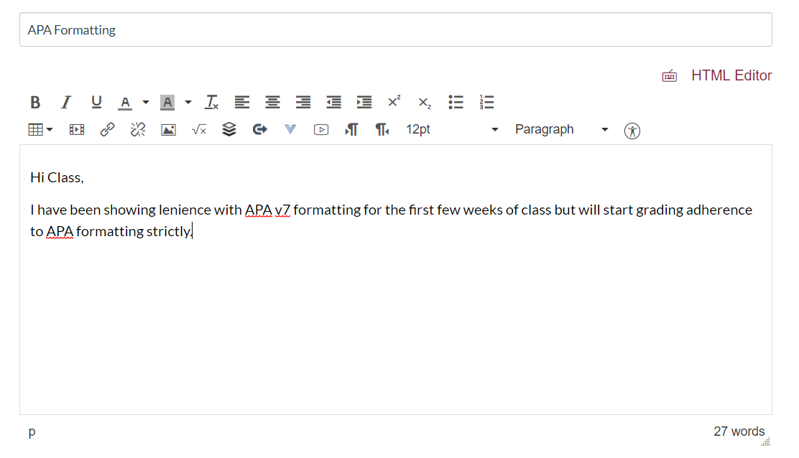

Note. You can add a note if the title does not adequately describe the screenshot or you want to add additional context. A note is not required.

Figure 2
The finished product
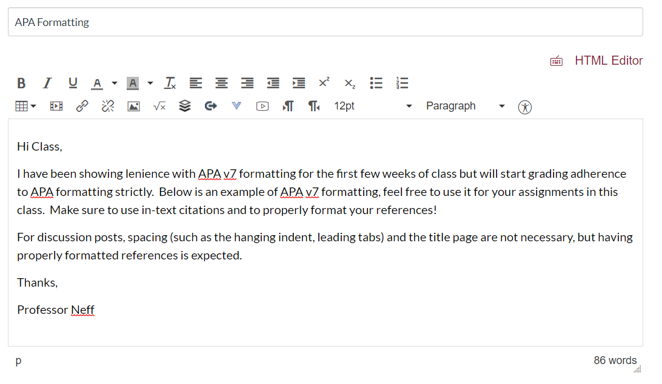

Note. Figures work best if they are embedded within the document as it is easier for the reader to follow, but can also be added at the end of the document.
References
Vocareum, cloud labs for learning. (2020). http://labs.vocareum.com

